
QUALITY ALERT

Customer: ChamClad Date: Jan 12, 2024
Die: 15751 Color: ANY
Type of Complaint: ChamClad COMPLAINED Customer NCR:

Description: ChamClad COMPLAINS that material is packed backwards, slow down laminating process.
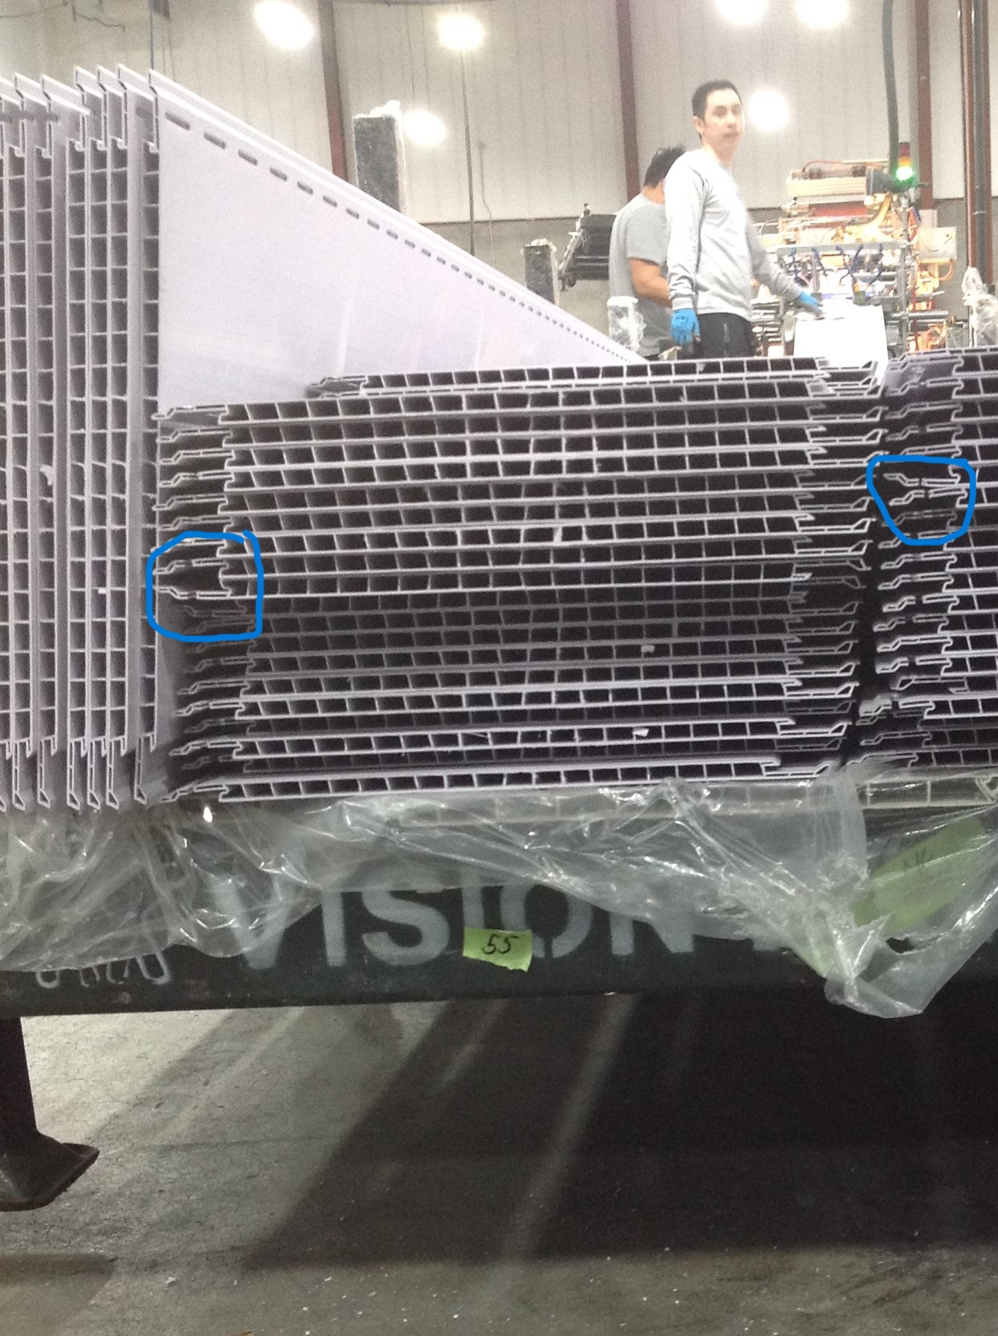

PLEASE MAKE SURE MATERIAL IS PACKED ON THE SAME DIRECTION
BY SIGNING BELOW, YOU ACKNOWLEDGE THE PROBLEM ABOVE AND AGREE TO MONITOR THIS ISSUE IN FUTURE PRODUCTION RUNS.
DAY SHIFT |  | AFTERNOON SHIFT |  | NIGHT SHIFT
NAME | SIGNATURE | NAME | SIGNATURE | NAME | SIGNATURE

